

Run N Gun Game design document

Group R – Ciaran McMahon(40291478), Calum Chittleborough(), Mengzhao Yang(40190241)



Contents

Document History 1

Overview and Vision Statement 1

Inspirations 1

Player Experience Goals 2

Audience and Platform 2

Legal Analysis 2

Gameplay 2

Overview 2

Player Mode 2

Screen Mockup(s) 3

Formal Elements 3

Players 3

Objectives 3

Rules 3

Boundaries 3

Outcome 3

Controls 4

Levels 4

Editor 4

Characters 4

Story 4

Game World 4

Required Media List 4

User Interface Assets 4

Environment Assets 4

Character-based Assets 4

Animation Assets 4

Music Assets 4

Sound Effect Assets 4

Technical Specification 4

Development Platform and Tools 4

Delivery Mechanism 5

User Interface Technical Requirements 5

Controls Technical Specification 5

Network Requirements 5

Flowchart 5

# Document History

Version 1.0 – 17/02/2018

Version 2.0 – 18/02/2018

# Overview and Vision Statement

This document is for the design of the game currently known as “Run N Gun”. It is based upon other 2D shooter games and their elements that were covered in the games engineering module. Team R is made up of three people: Ciaran McMahon Calum Chittleborough and Mengzhao Yang.

Our vision for “Run N Gun” is to have it fully functional and completed to the best of our combined abilities in a very effective and time efficient manner.

# Inspirations

Our inspiration for “Run N Gun” comes from many of the modules game examples that we have been working through like Pong, Space invaders and Pac-man. As well as the module material we have taken a lot of inspiration from all other top down shooter games available. Left 4 Dead is also a massive part of the reason behind “Run N Gun” but in a single player sense instead of relying on a team of people to help you.

A picture containing LEGO, toy

Description generated with very high confidence 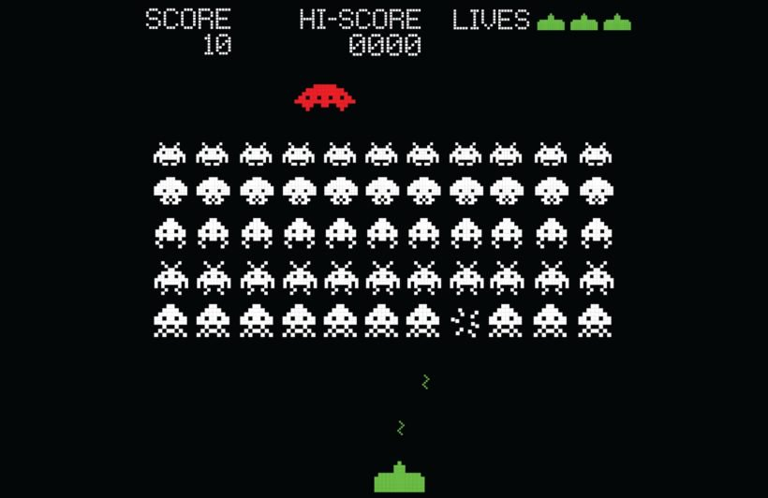

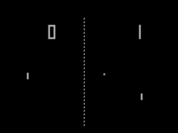 A group of people walking around

Description generated with high confidence

# Player Experience Goals

The main part of the player experience is to survive! The user must survive until the time runs out while building up a score by destroying the enemy sprites(Zombies) to top the leaderboard. The time limit will add a sense of urgency and danger to the player experience and the score will give them a more competitive reason to play.

# Audience and Platform

Our audience for “Run N Gun” is people of all ages. It is a tense and fun experience we are going for, so we are aiming to have it playable for everyone as it won’t be too gory. The target platform is PC and the hardware requirements will not be very demanding. Minimum requirements will be Windows 7. The game will be run from a .exe file so no installation needed.

## Legal Analysis

There should be no legal issues with this game. We will be creating our own resources to use in the game. The user and enemy sprites, background, powerups and other assets. We may use royalty free 8-bit music in this game if it is available. Financial issues won’t exist. The game idea is one that has been touched upon hundreds of times but the look and all resources we use will be our own so copyright claims should not appear.

# Gameplay

## Overview

The user is in control of a sprite that is placed on to a 2D top down field, they have basic movement, they can move up, down, left and right. The user can shoot the enemy sprites(Zombies). The enemy sprites spawn in waves so when they are destroyed by the user the next wave will spawn in and be a larger amount. The user must survive until the time expires while destroying these enemy sprites to build up a high score. The user can take damage off the enemy sprites and if too much damage is taken the game ends. Power up will spawn at certain point in the game gibing the user different abilities.

### Player Mode

The game for now is purely single player. Two players is something we are interested in trying to implement.

## Screen Mockup(s)

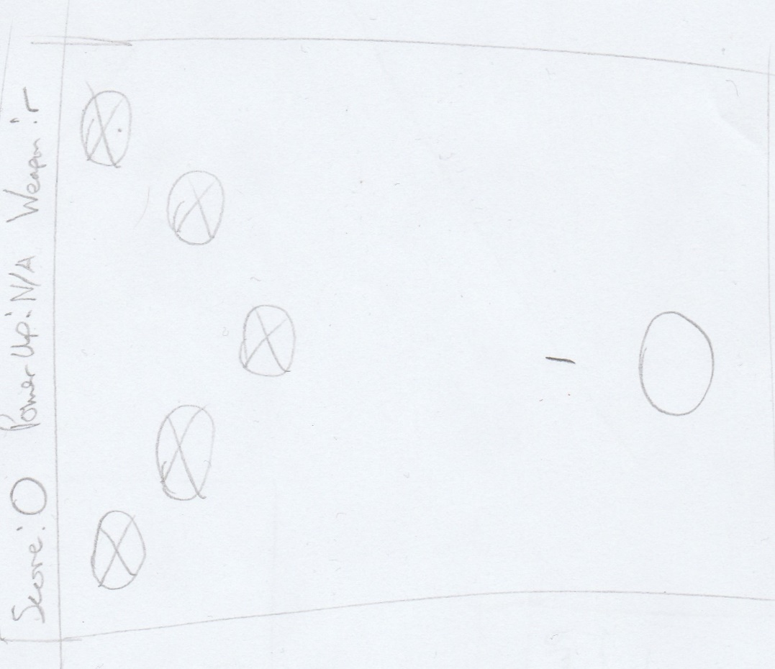

## Formal Elements

### Players

One user-controlled player.

### Objectives

To survive until the time expires while killing as many zombies as possible.

### Rules

Survive without dying.

### Boundaries

The screen shown will be the boundary of the game

### Outcome

The outcome will always be death but depending on how many zombies they kill they could top the leaderboard.

## Controls

User interface requirements, rules (from formal elements) and scoring / winning conditions should be included.

## Levels

There will be multiple stages, once the wave has been destroyed a new stage will be loaded.

## Editor

No editor will be created for now.

## Characters

There are two main sprites, the user-controlled sprite and the enemy AI zombie sprites.

## Story

## Zombies are overrun, and death is everywhere, as human you can’t no longer in silence,

## zombie assault is about surviving against waves of zombie, use your gun to survive the zombie apocalypse

## Game World

There is no world, but different stages(backgrounds) are what we are wanting to have instead.

# Required Media List

## User Interface Assets

The interface will be give the user the option to start the game and to see the leaderboards.

## Environment Assets

Different backgrounds created for different stages, like road setting, back alley etc.

## Character-based Assets

User sprite and zombie sprite

## Animation Assets

User sprite movement and shooting animation

## Music Assets

A royalty free 8-bit background soundtrack.

## Sound Effect Assets

Zombie dying and moaning/groaning sounds. User shooting and dying sounds. Game over sound as well as sounds for picking up powerups.

# Technical Specification

## Development Platform and Tools

Visual Studio 2013, language is C++.

## Delivery Mechanism

Online.

## User Interface Technical Requirements

Aiming for 1280x720 resolution.

## Controls Technical Specification

Only a keyboard and is required to play this game

## Network Requirements

It Is a standalone single-player game.

## Flowchart

